Day 14 - 2/7/2025
Barghavi Bethu
112728766 – bethubal

Task 1:
Create a custom node , add elements to it and traverse it..
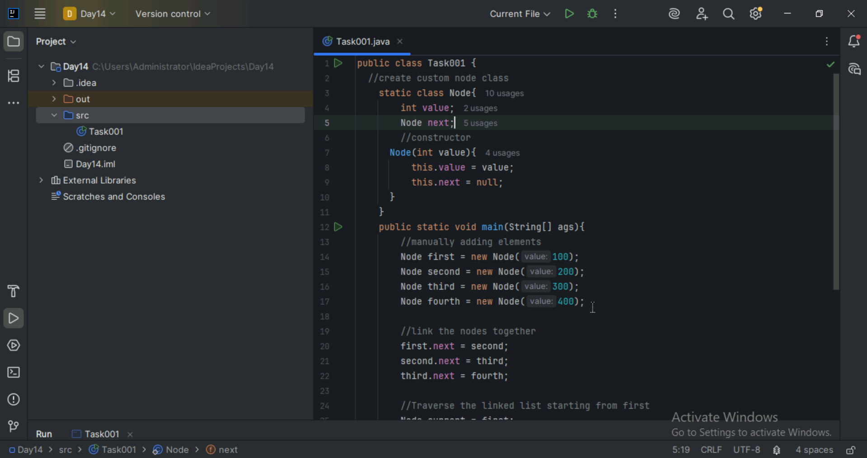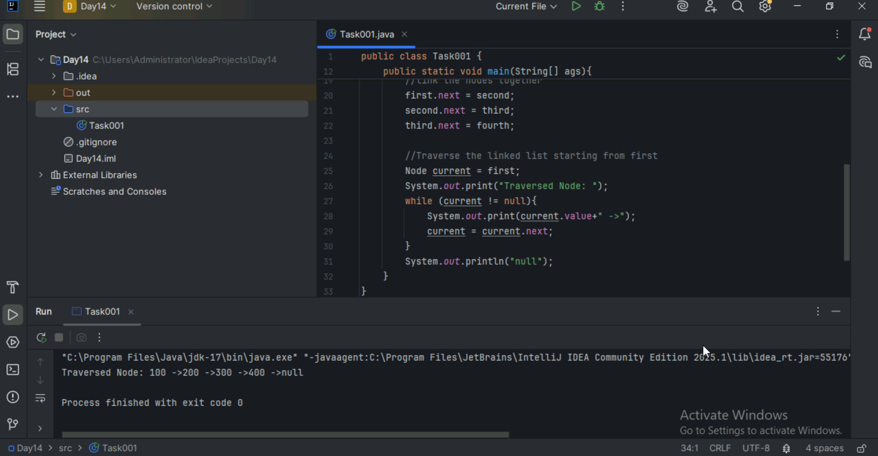

Task 2
What do you understand by traversing elements in a linked list.
Traversing a linked list means visiting each node one by one starting from the head(first node) and performing some action – usually accessing or printing the data stored in each node. Traversing is important to read or display all elements, to search specific values or to apply changes to each element. Traversing logic is it start at head node, while the current node is not null process the data and move to next node.

Task 3:
Create a Circular Linked list using Task 1 Singly linked list.
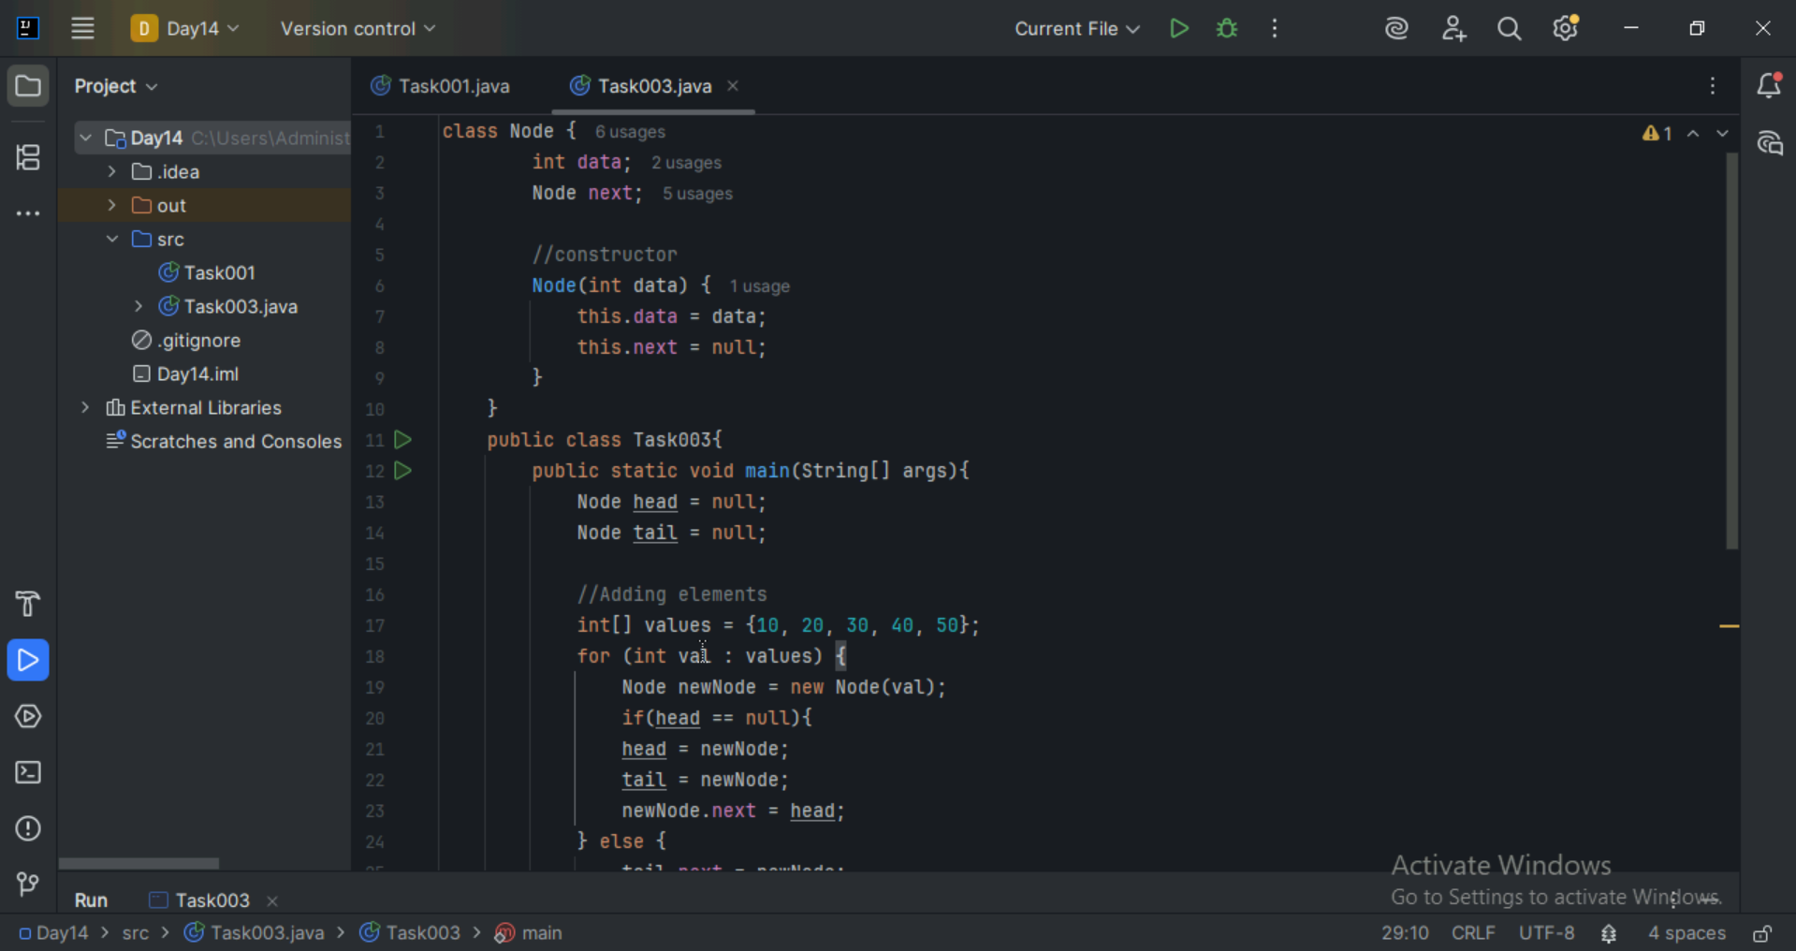
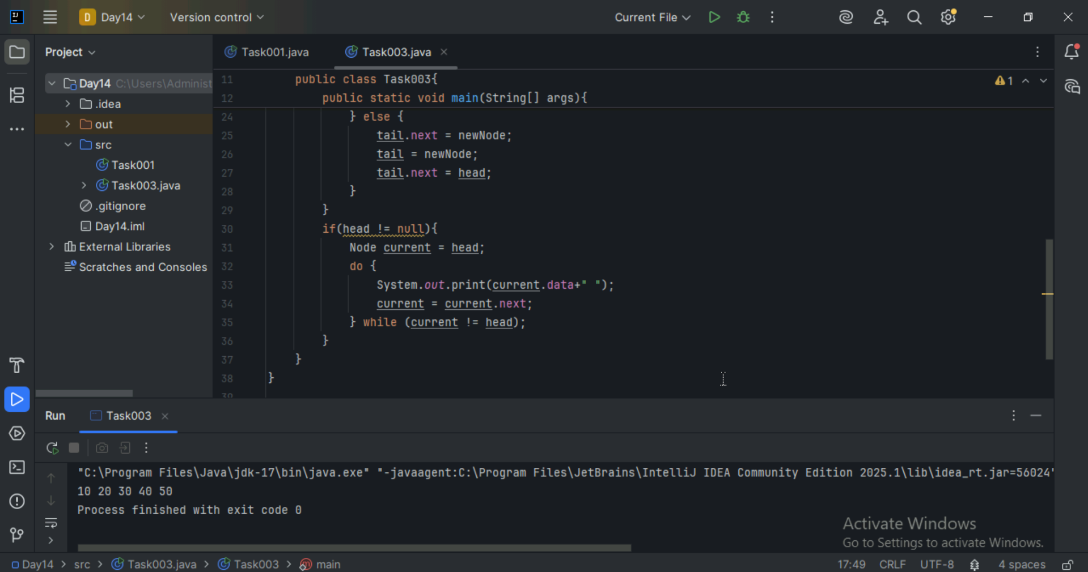

Task 4 :
Stacks
Create a code to implement a stack
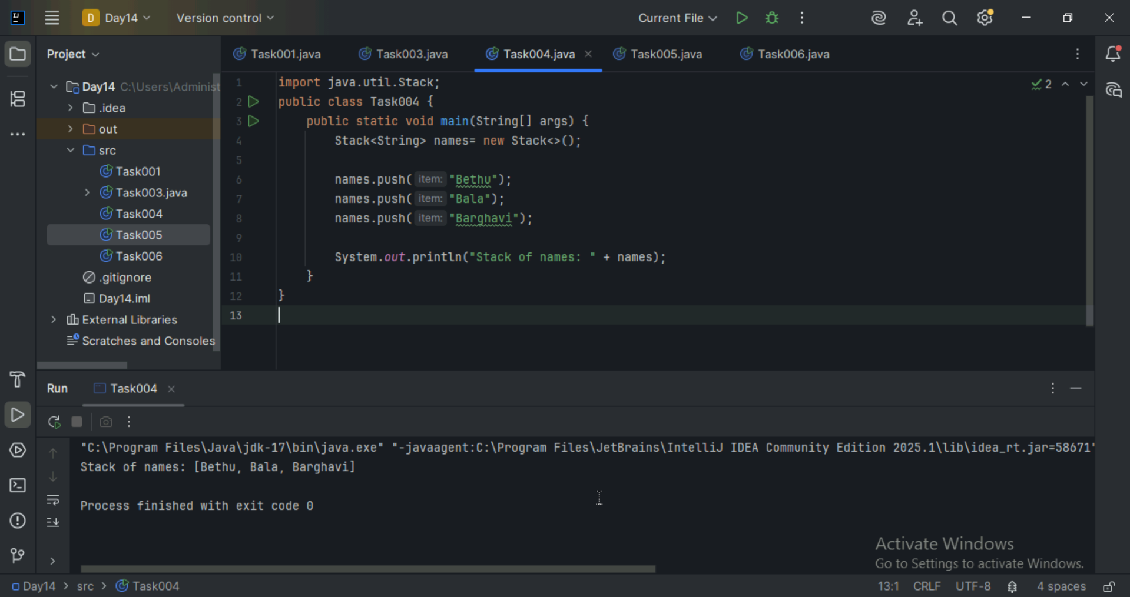

Task 5:
Create astack and pop the element also print the popped element.
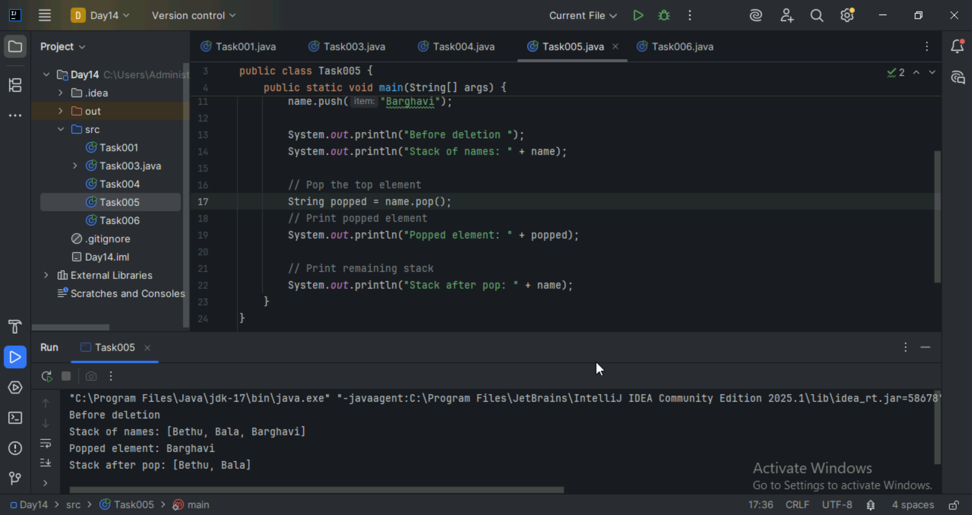

Task 6:
Find an element in the stack and display the position.
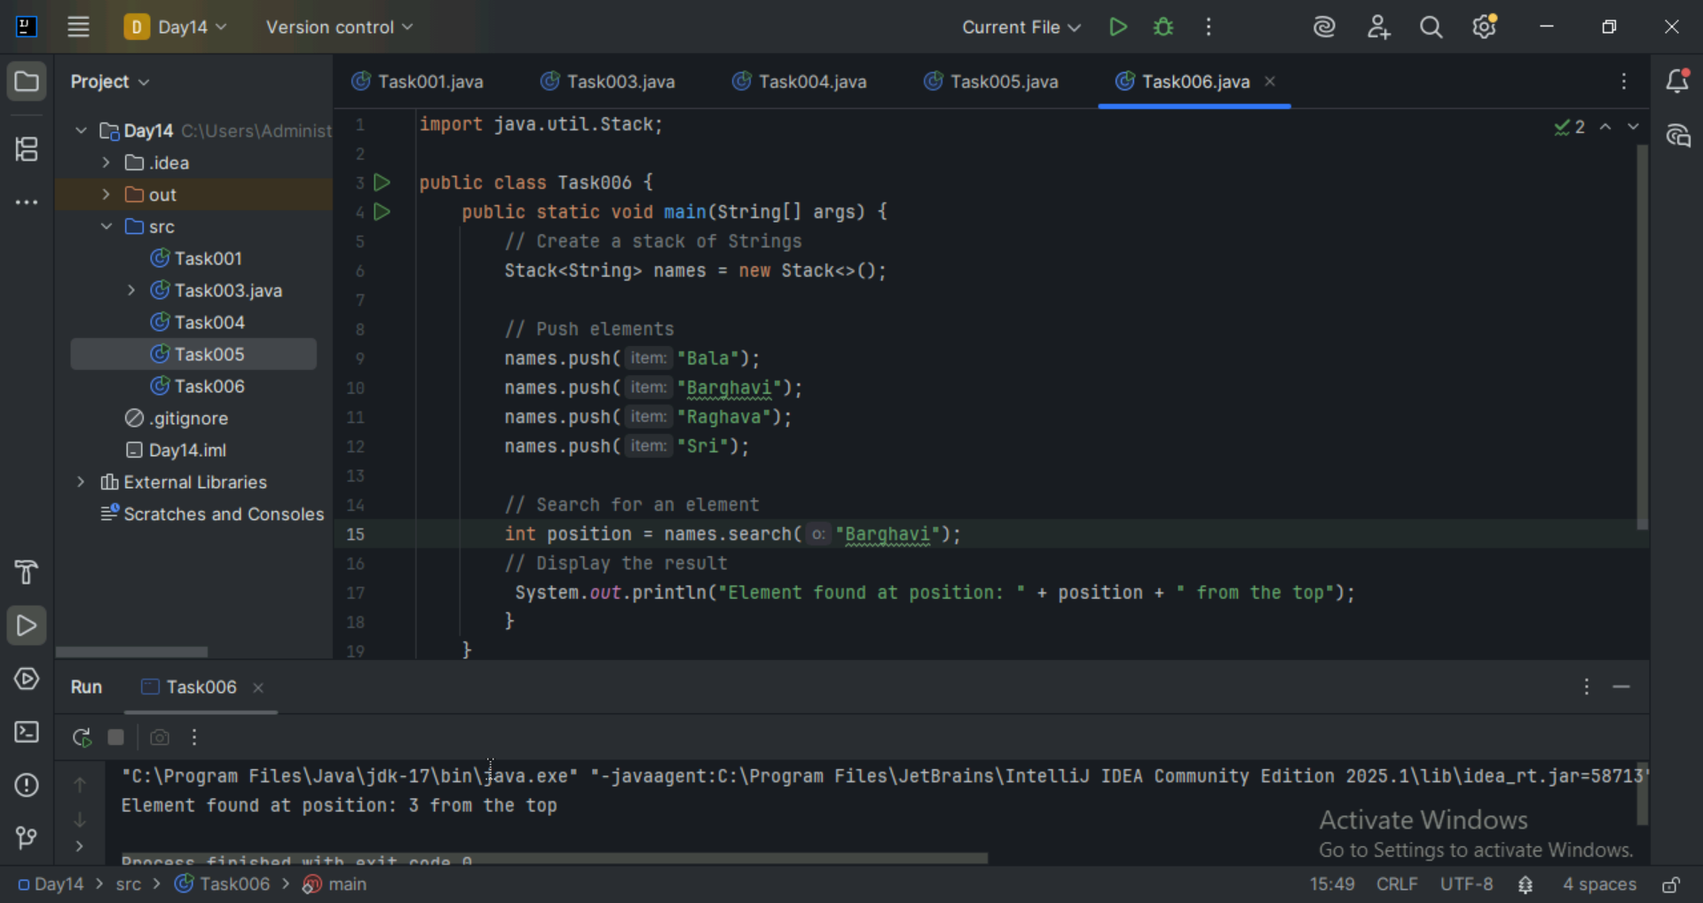

Task 7:
Peek the element and print it ..
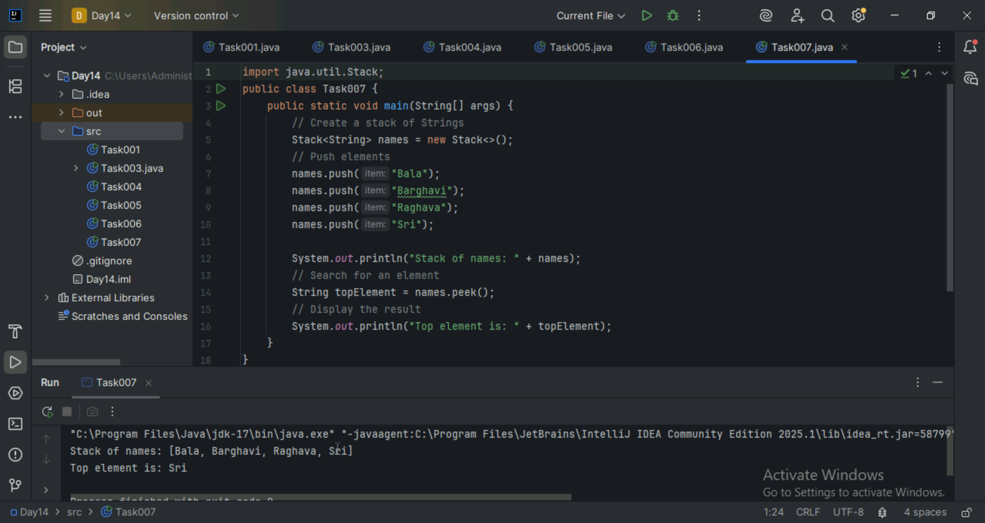

Task 8:
Check if the stack is empty or not?
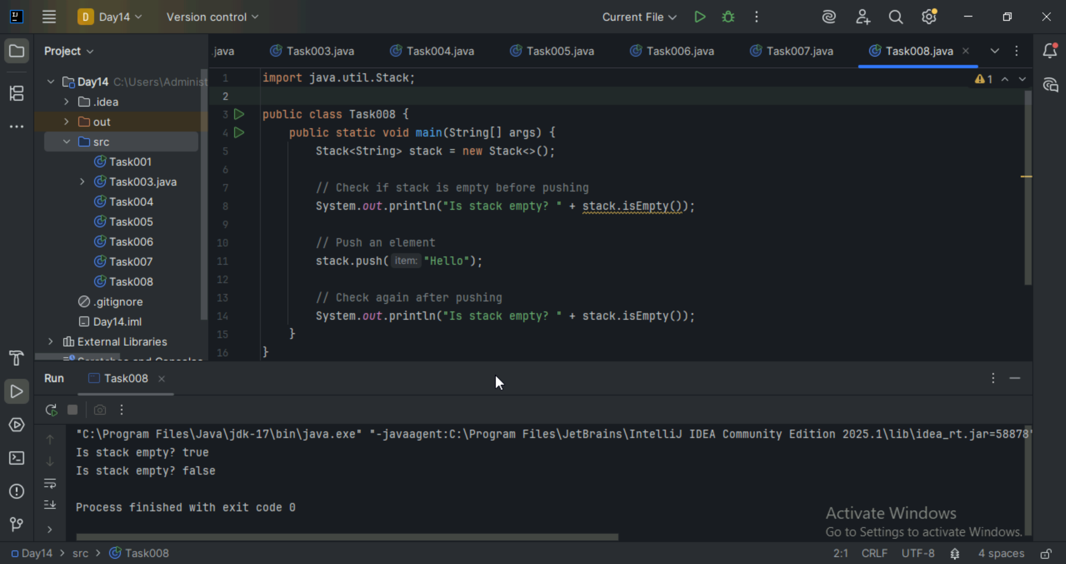

Task 9:
What are the methods of the stack class
Push(E item), pop(), peek(), search(Object o). isEmpty(), add(), remove(int index), size(), clear(), get(int index), contains(Object o).

Task 10:
What are the common operations in Queues
Enqueue, Dequeue, Peek/Front, isEmpty(), isFull(), Size, Display

Task 11:
Wap to create a queue with custom methods
Is empty ()
Is full()
Enque
Deque
Peek
display()

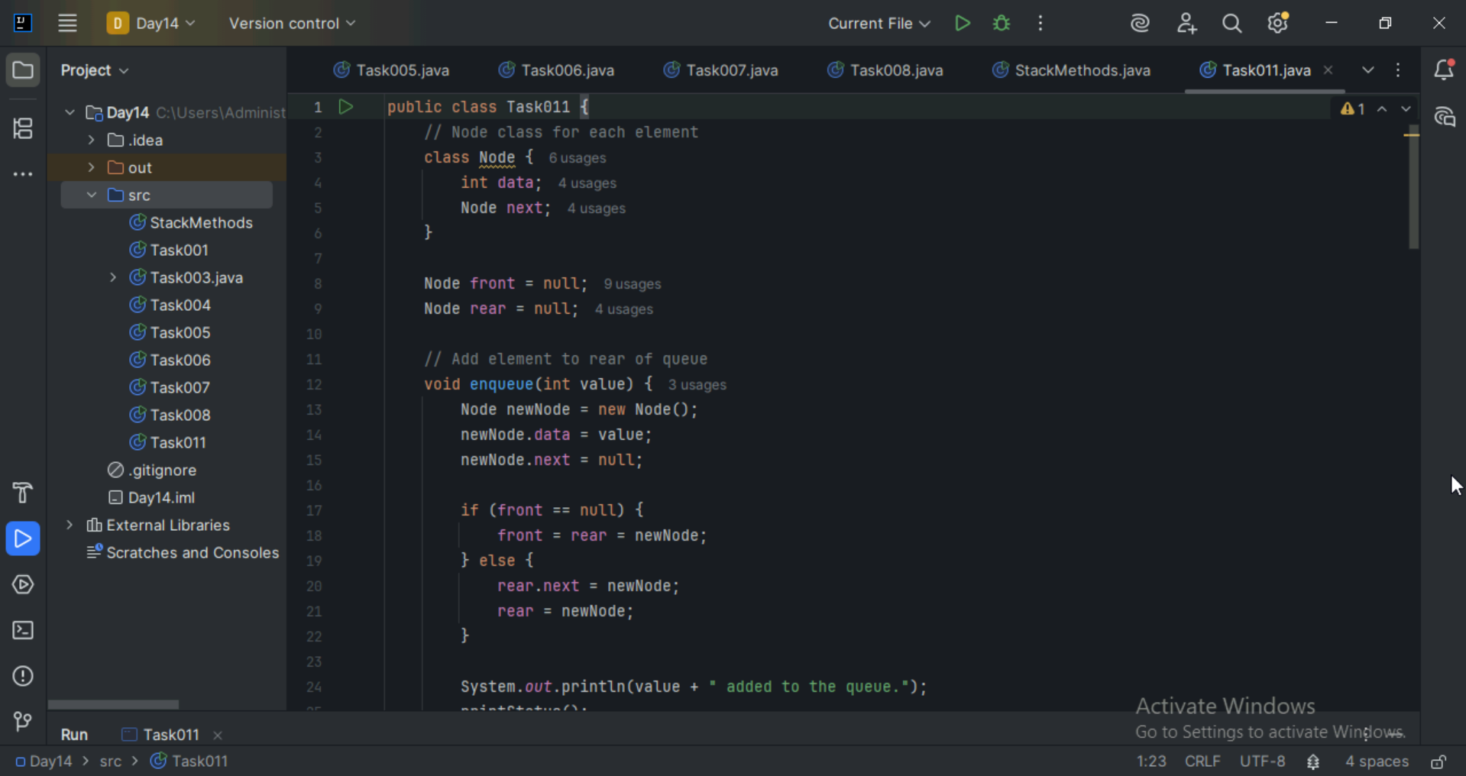
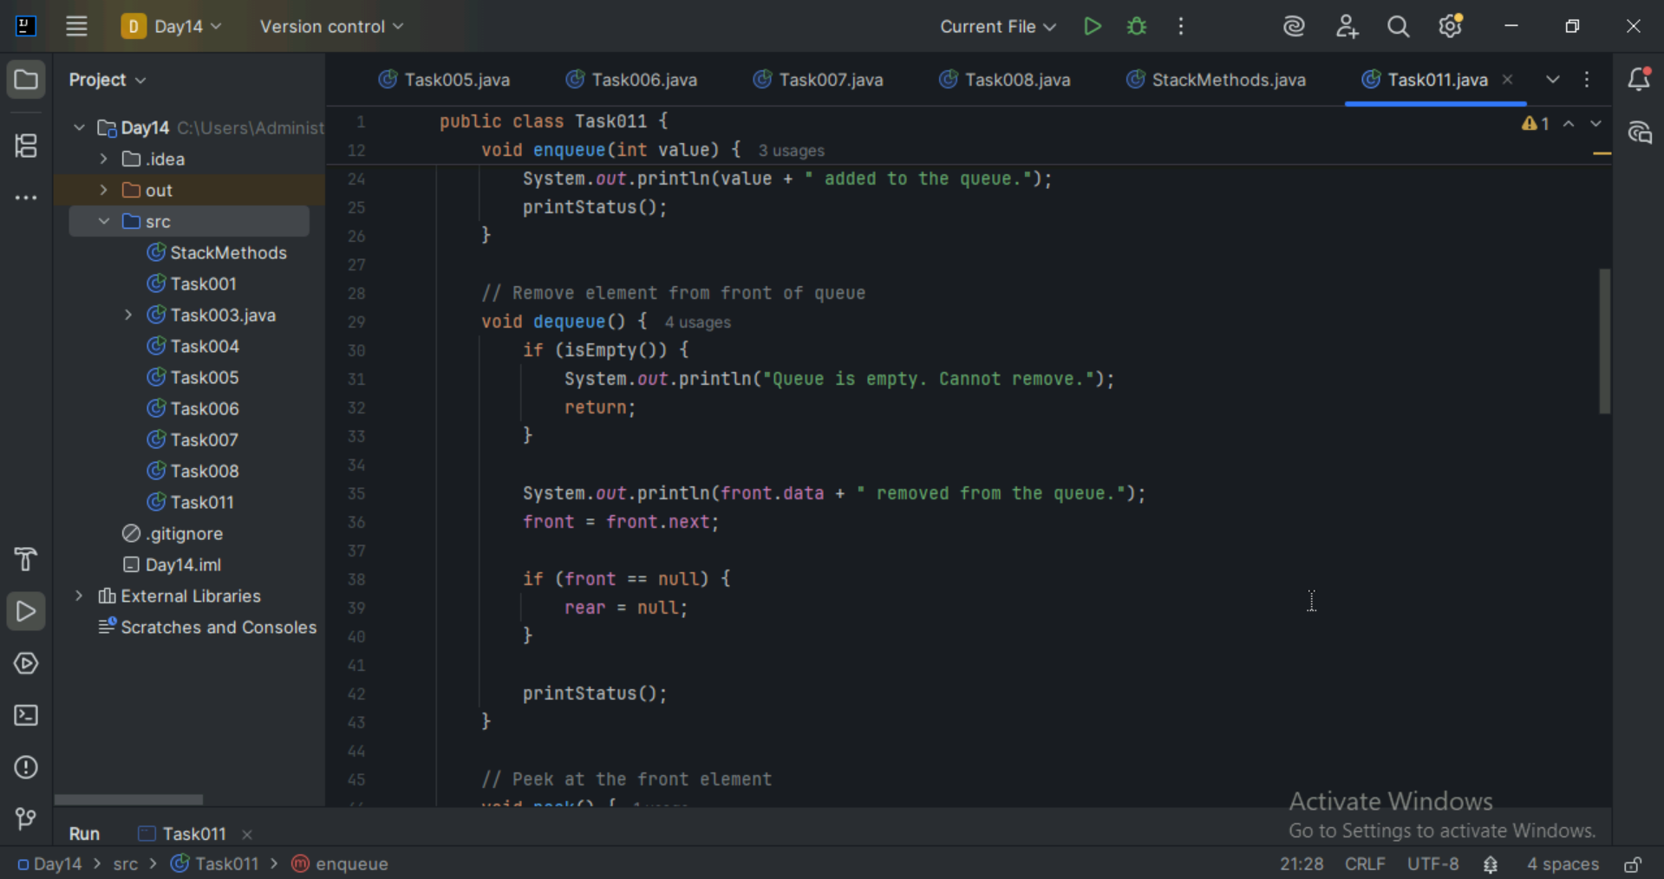
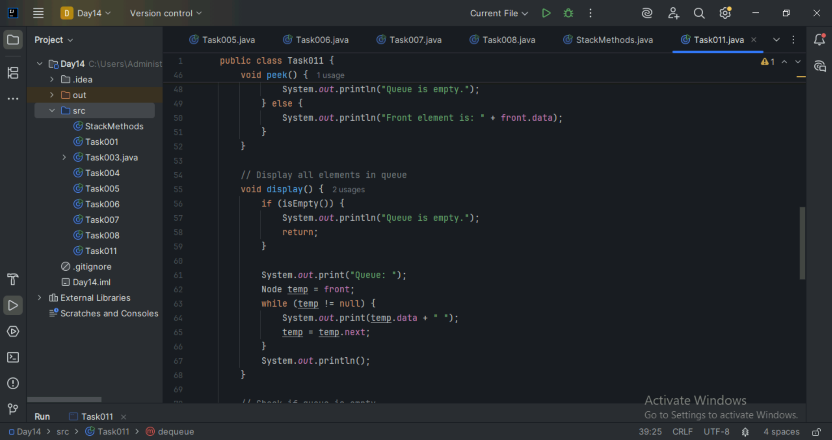
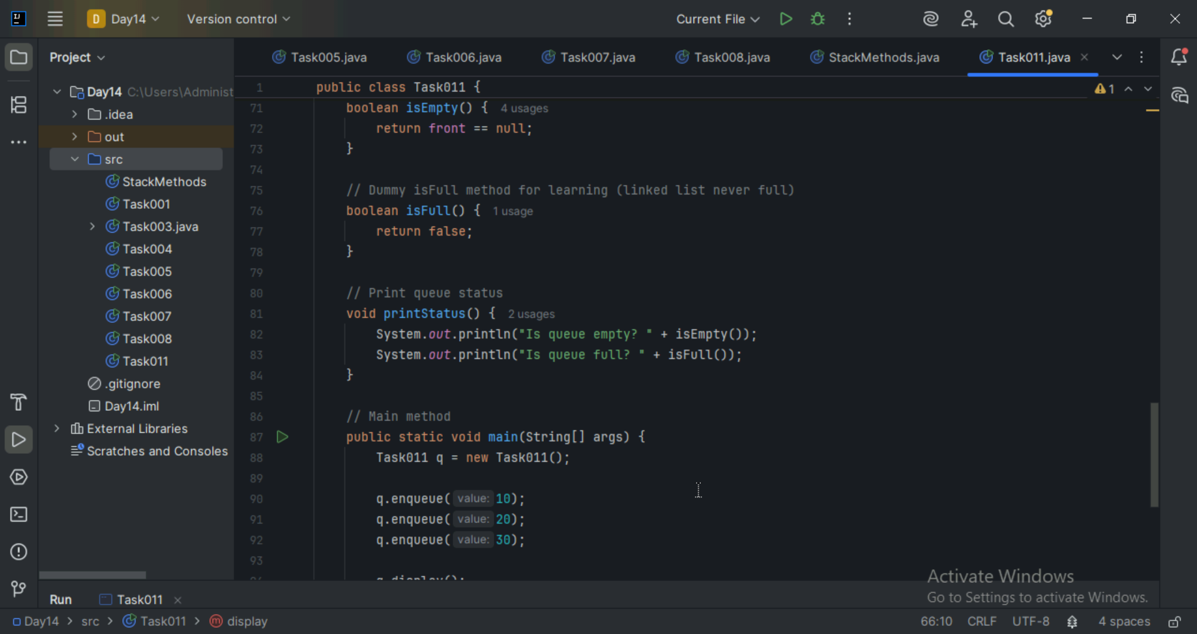
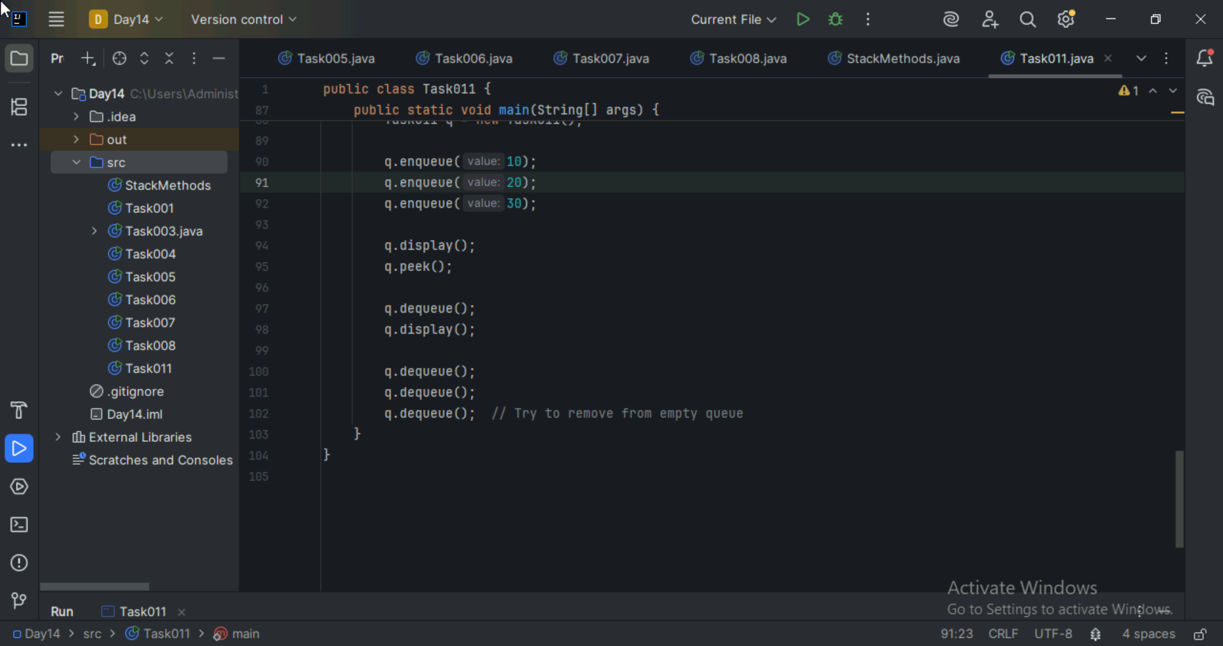
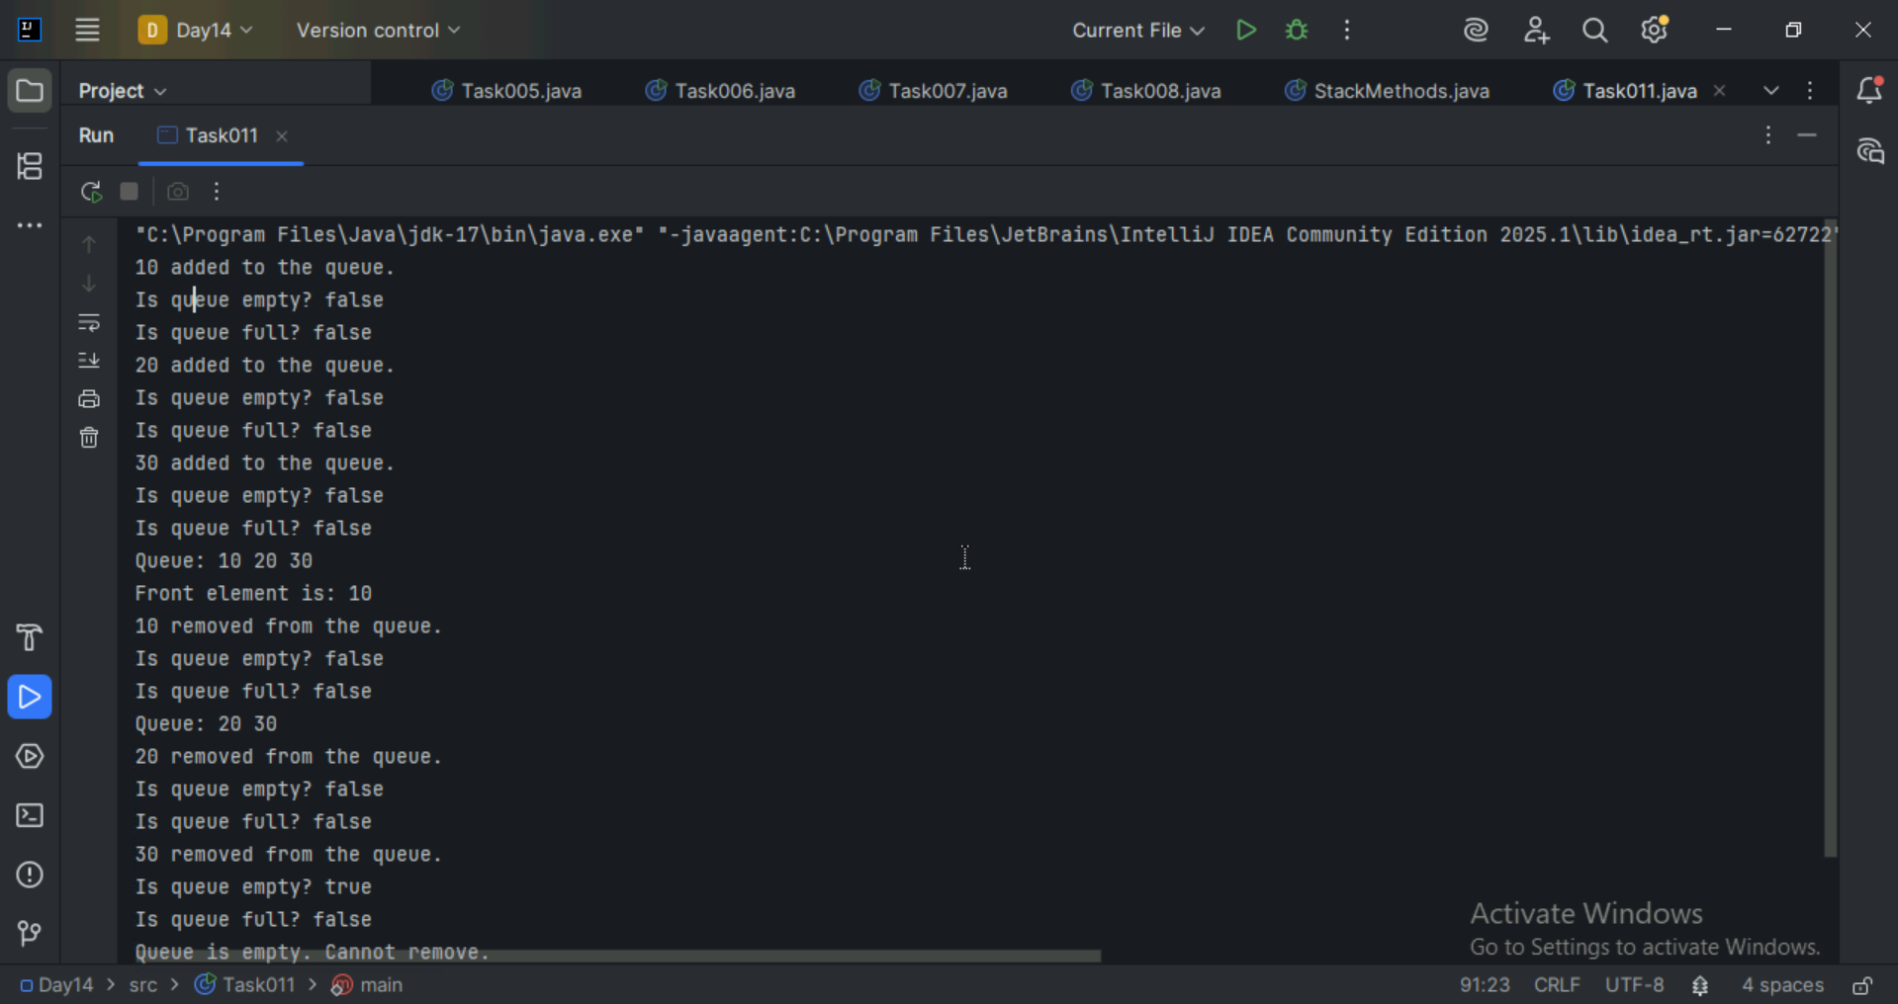

Home Tasks:

Recursion:

Wap to find the factorial of a number
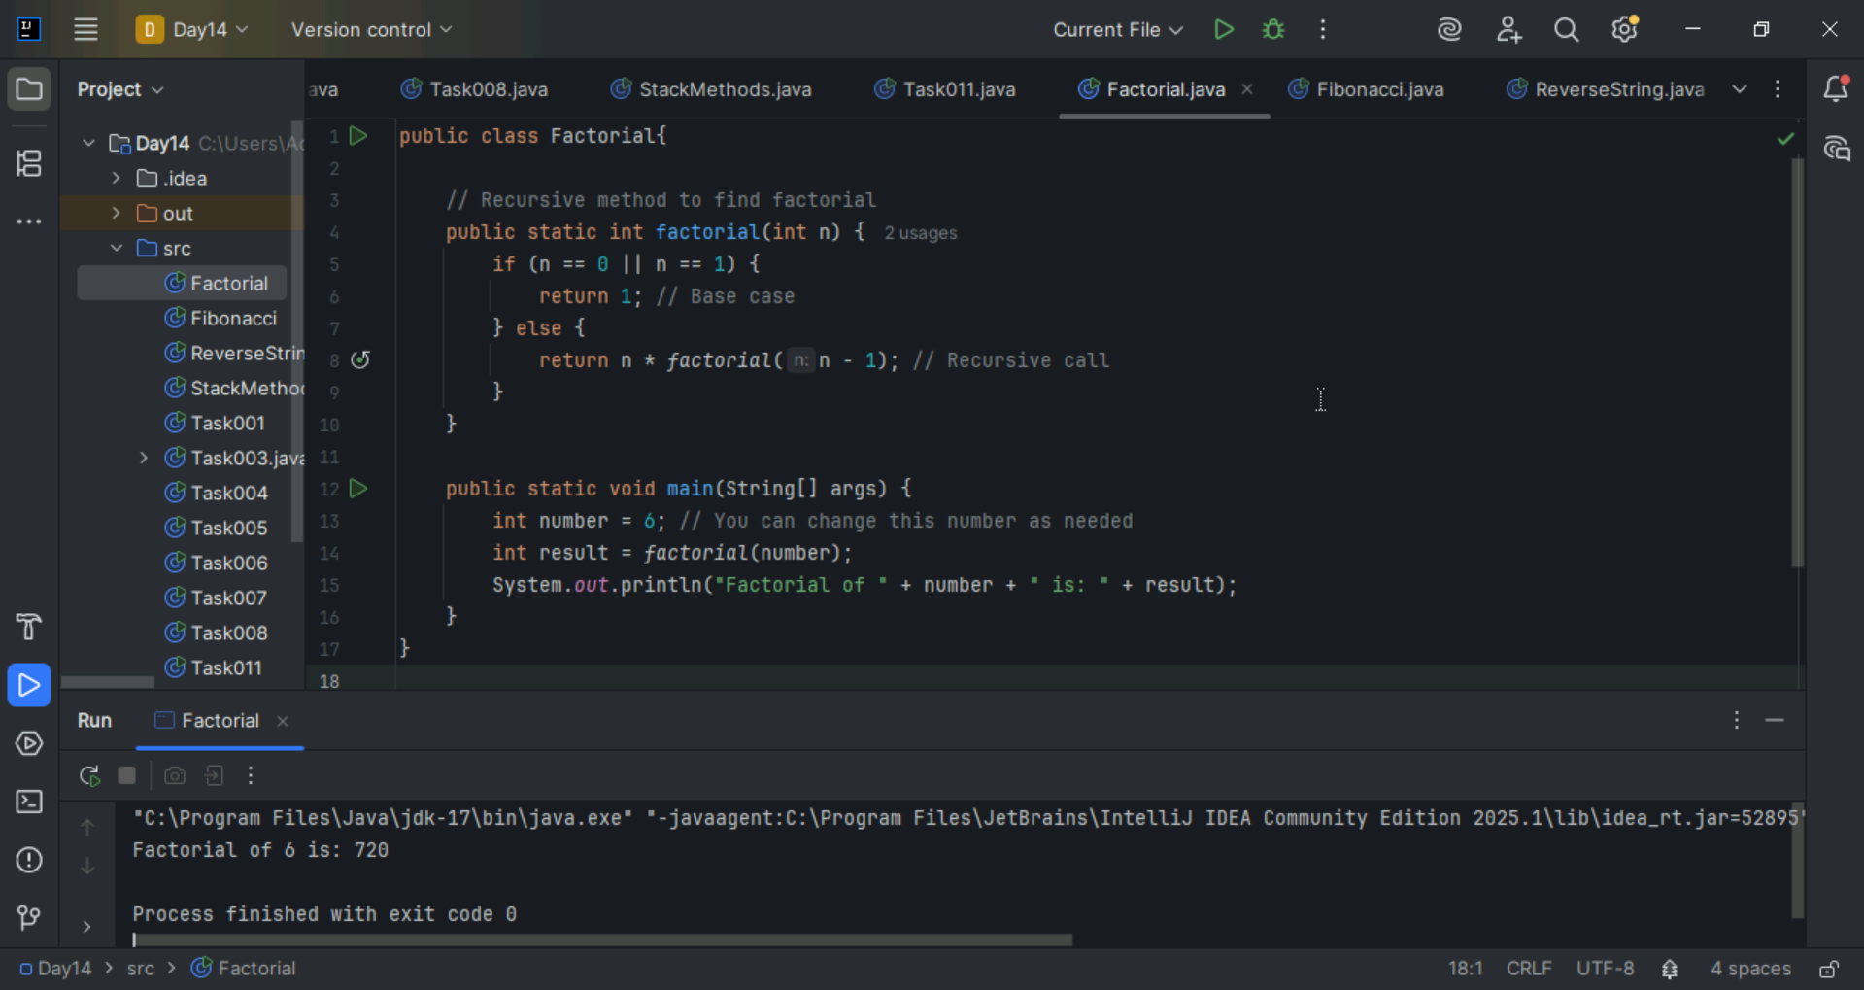

Wap to find the Fibonacci series of a number
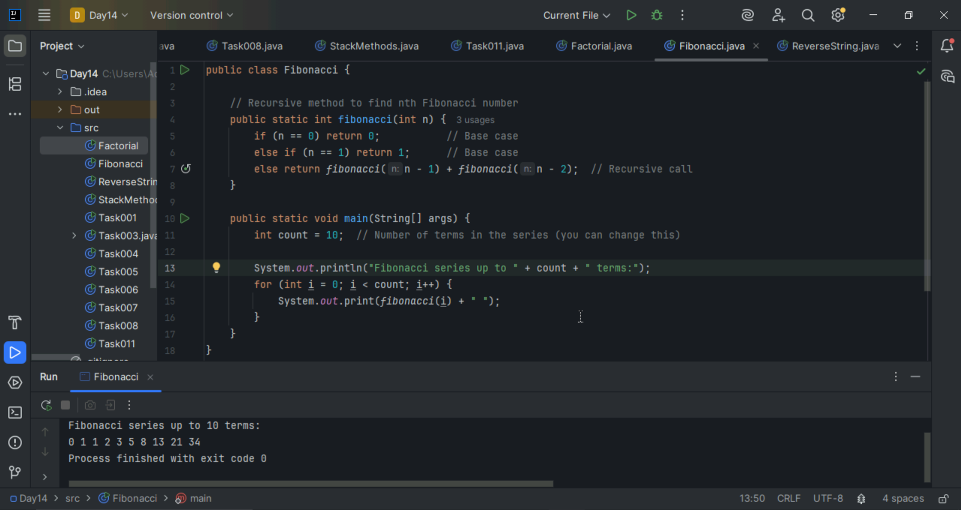

What is the difference between recursion and iteration
Recursion: A function that calls itself to solve smaller instances of the problem.
Iteration: Repeats a block of code using loops until a condition is met.

Wap to reverse a string using recursion..
